**PRACTICAL: 8**

**Develop a complete UI design process**

**What is User Interface Design?**

Every human-centered design project starts with the user interface (UI) design process. Designers use it as inspiration to create a page or product that stands out from the competition. User interface design is the front face of your product and users interact with it when they come to use your product. UI design behaves as a layer between the user and the functionality that your product is providing. While creating a UI design the designer must have a good knowledge of user interface elements and controls like buttons, menus, text boxes, lists, dialogs, icons, etc. By combining all these elements on screens, designers create a product that attracts users with its look and feel.

**1. Set design goals**

The first step in the UI design process is to specify the goal your team needs to accomplish. Design solves the problem therefore to provide the solution you first need to understand the problem. For this purpose, the design teams rely on design briefs. A design brief is a document that outlines all the essential components of the design project. It serves as the project's backbone and a communication tool for the customer and designer. In short, the design brief gives the designer an idea of what the user needs in the product and what type of design will fulfill his needs and requirements.

While creating the design brief the following points must be listed:

**Highlight goals and objectives**: In the beginning, you need to mention the purpose of creating the design. Talk about what it does and what it wants to accomplish. In the absence of a clear objective, there is a chance that designers will waste their time in creating something that clients don't even want to use.

**Target audience details**: You must specify your target audience precisely in the design brief if you want the design to be flawless and right on point. For example, a flashy design might be appropriate if teenagers were your target market. If your audience includes older adults, you would need a modest, straightforward design that effectively communicates your message. Similar to this, if your target market consists of people who will work 9 to 5, you'll need a design that grabs their attention right away because they're busy all day.

**Scope**: The design brief must describe in detail what needs to be covered in this product. Is this a new website or application, or enhancements to an existing product? A clear scope helps designers to put their efforts in the right direction and save both time and resources.

**Success criteria**: It includes the “key performance indicators (KPI)” and “objectives and key results (OKR)” set by the product manager to fulfill the criteria of designing a successful product.

**Project team**: This describes the team working on product design tasks along with the details of tasks and responsibilities assigned to each member and the stakeholders involved in the project.

**Deadline**: The design brief should tell about the delivery date after discussing it with the client. A realistic deadline will help designers complete the product design on time and hence avoid any unpleasant situation.

**2. Conduct user research**

The purpose of user research is to determine the problems the users are facing and what they need to do to resolve those problems.Putting ourselves in users' shoes helps us find the way they are thinking and behaving. Below are the few methods and tools that help to conduct successful user research.

**Research**: To design a product, you must know about user needs and their requirements. User research helps to understand users and their problems. There are various ways of doing user research, for example, you can use Google or other search engines to find out how users are interacting with existing products in the market. How those products are designed and developed? Are users happy working on those products? Are there any required improvements that you can handle in your upcoming product?

**Interview + observation**: Your most important task is to understand what exactly the user wants from your product. You can do this by taking feedback from users regularly.Meet users and ask questions about what they want to achieve using your product. Observe them in their working environment and see how they handle their daily problems. This will give you a good understanding of what users think and you will design your product accordingly.

**Survey**: To know the demands of a large number of users you can carry out a survey. The findings of user research surveys are used to create user personas and provide the answers to queries like how do people utilize our website? And do users encounter any problems with our product?

The UI designers utilize the UX research survey tools to gather user input on their website or product. Using various online (online focus groups, user interviews) or offline (mail surveys, phone interviews) routes, data is collected when conducting user research surveys.

**3. Empathize with users**

This stage of the design process is very critical and has a great impact on the outcome of the product. Understanding the users' needs and thinking of the best possible solution can be done when you know your users. For example, if you are designing a product for doctors, then you will design the product according to their requirements. A doctor can need a patient record, appointment details, invoices, and types of treatments provided to the patient. Now UI/UX designers will only know about all these requirements if they have carried out the process of empathizing with users.

Below are tools and methods to help you better understand your users.

**Empathy map:** An empathy map is a simple visual tool that captures knowledge about users' behaviors and attitudes.It is important to use empathy maps from the beginning of the design process to prioritize users' needs. A traditional empathy map captures four levels of information: what the user **says**, What the user **thinks**, what the user **does**, and what the user **feels** when he/she is working on a product or a usability study. This information helps you to

* Develop a common and shared understanding of users
* Discover weaknesses in your user research
* Uncover user needs that sometimes even they don't know about

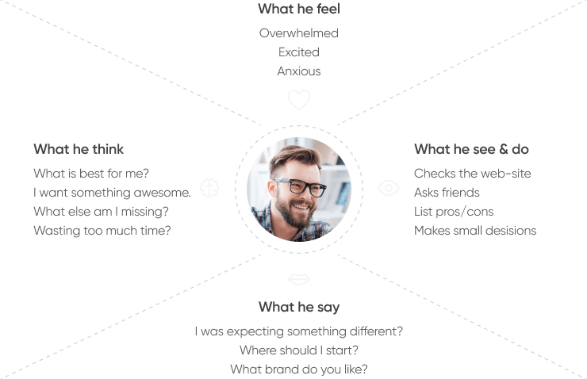

**Personas:** Personas help to define a standard representation of your users' behaviors, challenges, and motivations. Personas make it easier to define user segments and target them while making design decisions. Defining personas is important for a product as they drive the design decisions at each stage of the process.

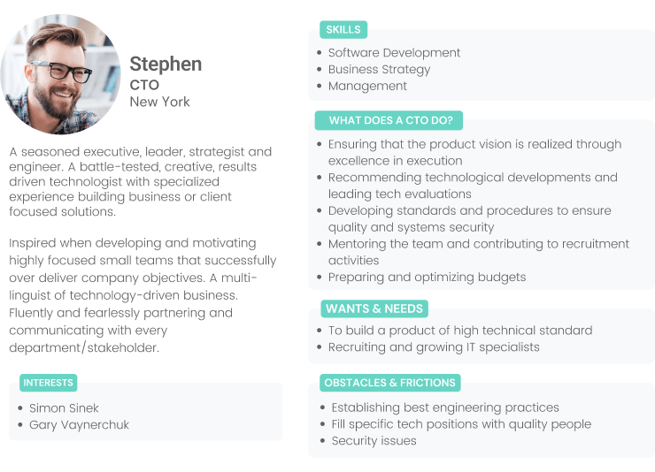

**Scenarios**: Define specific user scenarios where a specific user wants to achieve a specific goal using your product. Then think about the best possible experience for users to complete that scenario. Only when you know who will do what on your product, and how and why they do it, then you can define a design that closely matches the actual requirements.

**Storyboard:** The storyboard allows you to create a low-fidelity visual that focuses on users and their actions, thoughts, goals, emotions, and relationships. This covers a specific situation or scenario and helps you to view the sequence of actions that the user will perform to complete that scenario. A short description of the scenario is mentioned on the storyboard. Sharing storyboards among stakeholders helps you get feedback and improve your ideas.

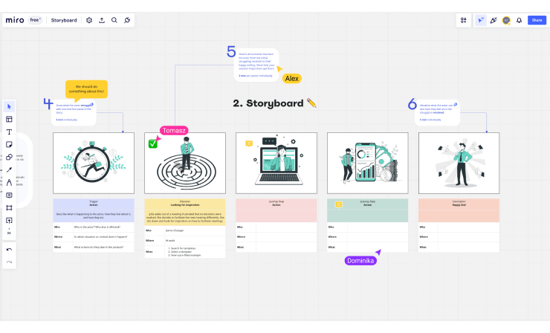

**4. Choose a design concept**

During this stage of the process, a UI designer starts creating a digital product's graphical user interface. This includes defining layouts, deciding the information architecture, creating icons, selecting the color theme, defining typography styles, and setting UI guidelines.

**Ideation map:** Ideation is the process of implementing various ideas and seeing how they work. By following this approach you can figure out both positive and negative aspects of your idea. By feeling the problems coming from negative aspects, and the positive feelings coming from positive aspects, you can finally figure out the solution for the problem and make a final design that will be successful.

A visual ideation map helps you better organize these feelings and hence makes it easier to decide on a solution. List down the negative feelings on the left side, and the positive feelings on the right side, and then compare and think about the possible solutions.

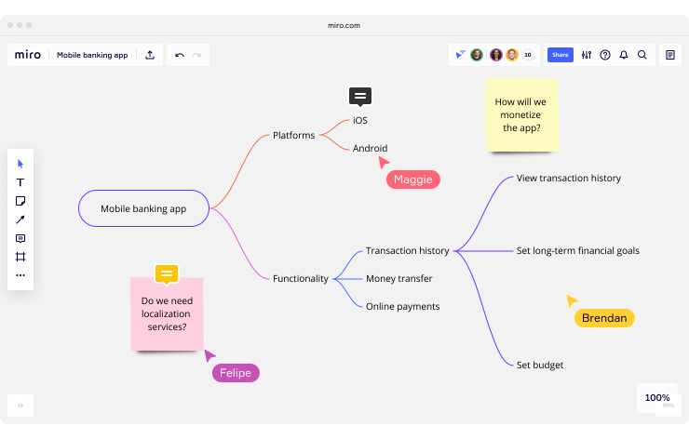

**Moodboard:** A moodboard defines the visual look of your product design. By combining a collection of images, styles, text, colors, and icons, you can present the layout of your product that helps a wider audience to understand the purpose of your product. By arranging UI elements in different ways, you can create multiple moodboards and then decide on the best one based on the audience feedback.

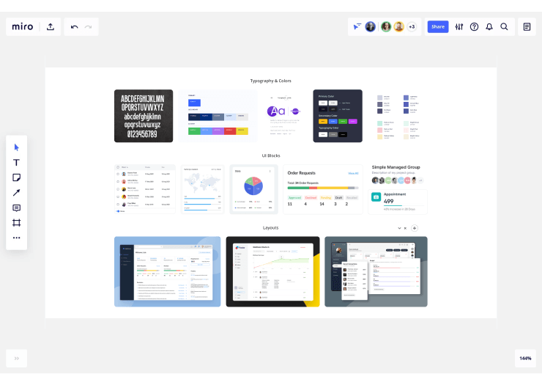

**5. Prototype the design**

With the screen layouts defined, during this stage your team can begin design work in the form of sketches. Paper sketches, whiteboard flows, and wireframes help you share your design ideas with stakeholders at the early stages of the process. This makes it easier to get feedback and do multiple iterations. The objective is to create a usable design to achieve user satisfaction.

Working on your wireframes can begin once the appropriate sketch has been determined for each screen. These low-fidelity mockups outline each screen's visual hierarchy and structural principles. After getting finalized, you can move to the high-fidelity design images with detailing and color themes.

**Flowcharts:** The user flow charts represent the flow of the screens the user will go through to perform certain tasks using your product. The flowchart begins with the entry point to your product, like a home page or a login screen, and ends with the exit point where the user completes the process by following several steps in the flow. User flows help designers depict the experience that users will get while interacting with the product.

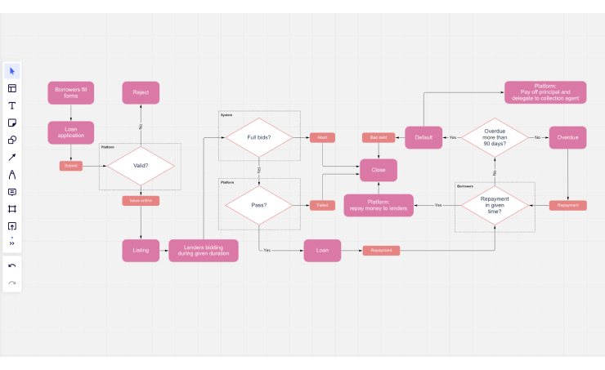

**Wireframe:** Wireframing involves the visualization of the skeleton of the digital products and applications. The wireframe shows which interface elements will be present on crucial pages of the application. Therefore it is an essential process in UI design. For wireframing, you can use multiple tools like Figma, Sketch, Axure and Balsamiq. After wireframing, you can design visual images and link the screens in a prototyping tool to create a digital prototype of your product. A prototype helps to visualize the product design in a way that is very similar to the working product. A few popular prototyping tools are Figma, Sketch, and Adobe XD.

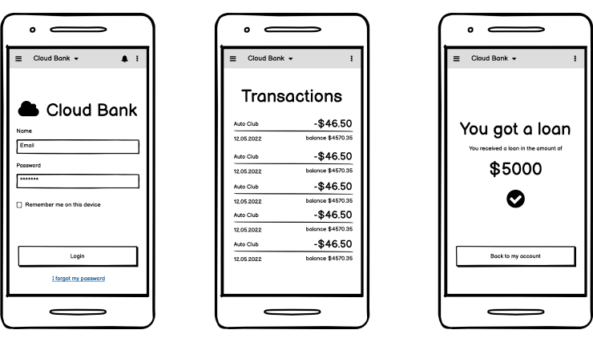

**6. Test and iterate**

A team can test the usability of the prototype as soon as it is finished. Unlike QA testing and A/B testing, the major objective of usability testing is to get opinions from actual users of a product to determine how user-friendly the interface is and whether the user can accomplish their objectives using the product. After successful usability testing the designer now documents and evaluates the test results. There are several types of usability testing as mentioned below.

**Comparative usability testing**: The comparative usability testing is done by comparing the two products which may be competitors of each other. Moreover, this type of testing can also be done by comparing two versions of a single product (A/B testing) and then selecting the best one. The purpose is to identify the positive and negative points of both products or design versions. It helps to choose an option to follow by testing multiple options with real users based on their needs.

**Explorative usability testing**: The explorative usability testing is conducted during the early design stages. This type of testing involves the exploration of different design ideas and identifying the design flaws and gaps. Before the release of a product, this testing helps to identify market demands that you should focus on.

**Usability evaluation**: Usability evaluation occurs after all essential modifications have been completed and the product is launched in the market. In usability evaluation, the product is again tested to ensure that it has a good impact on users. And they are completely satisfied with both the functionality and experience of the product.

Following user testing, designers can do multiple iterations of UI and UX design before handing off the design to the development team for implementation. The UI and UX designers provide any required support in the implementation process and perform an audit of the implemented UI and identify any gaps. They continue to work after the product is released and focus on further improvements in the experience.

**7. Refine and update**

After the release of a product when users start using it and successfully achieve their goals, the responsibility of UI/UX designers is still coming along. The UX/UI designers continue their work to keep the product updated as per new UI and UX design trends.

**Further testing and evaluation**: After the launch of a product in the market, the process of testing continues to ensure that the key functions of the product are working well. Also, the product is being tested in terms of required usability improvements. You can observe how the user interacts with your product and list down the outcome. Through this testing, the reiteration of different options is done and after A/B testing, the best option is released.

**Improvements and new features**: The UX designer follows up with new trends and understands the needs and requirements of users according to advancements in technology. To meet changing needs of users, the UX designers must update the feature set and work on designing them within existing products.

**Redesign**: Redesign is needed if the trends have been changed, or support to new user groups is required in the product. If a product needs to redesign, the team starts the process from the beginning, performing UX research, building the latest sitemap and wireframe, and having the UI designer produce a mockup and come up with prototypes, etc.

Although the design process stages and deliverables listed above are most commonly used to design a product, they can be customized based on requirements. Similarly, the deliverables at each stage can be skipped if not required. The result of the design process is to achieve the desired experience and user satisfaction.